Design Patterns Applied in the Banking Management System
The Banking Management System applies three design patterns to keep its architecture flexible and maintainable as features are added. The used patterns are one Creational pattern visible in the Class Diagram, and two Behavioral patterns visible in the State Diagram and the Sequence / Collaboration Diagrams. Each pattern is presented with the problem it solves, how it works in general, how it maps to our specific classes, and its trade-offs.

1. Singleton - Global Risk Model
Category: Creational

Problem
The Chief Risk Officer (CRO) sets a single set of global parameters (minimum credit score, maximum debt-to-income ratio, dangerous-loan thresholds) that every loan evaluation across every branch must reference (referring to UC 20: Set Global Risk Parameters). If each branch or each loan officer instantiated its own risk model, evaluations would drift apart and the bank would lose a consistent risk policy. We need exactly one shared risk model that is globally accessible.

How It Works
The Singleton pattern restricts a class to a single instance and provides a global access point to it. The class enforces this internally by hiding its constructor and exposing a static accessor that creates the one and only instance, then returns the same reference on every subsequent call.

Structure in the Project
The GlobalRiskModel class in the system class diagram is marked with the «Singleton» stereotype. Its attributes (maxDebtToIncomeRatio, minCreditScore) and its operation validateLoanParameters(loan) are shared globally. Loan objects call validateLoanParameters() against the single instance during evaluation, and the ChiefRiskOfficer actor mutates that same instance via setGlobalRiskParameters() (UC 20). UC 21 (Flag Dangerous Loans) then reads from the same instance to decide whether a loan breaches the threshold.

Pros
- Guarantees a consistent risk policy across every loan evaluation, branch, and underwriter.
- Parameter updates by the CRO propagate instantly system-wide, satisfying UC 20's zero-downtime requirement.
- A single controlled access point makes audit logging of risk-policy changes straightforward.

Cons
- Singletons behave as global state, which can complicate isolated unit testing of loan logic.
- If the bank later requires region-specific risk parameters, the Singleton must be refactored into a registry of instances keyed by region.

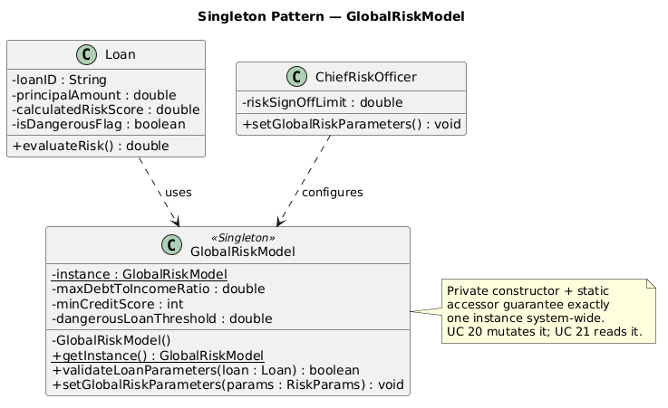

2. State - Account Lifecycle
Category: Behavioral

Problem
An Account behaves differently depending on its current status. A frozen account must reject withdrawals but may still accept deposits; a closed account must reject everything; an account under asset recovery has its own restricted set of allowed operations. Without the State pattern, the Account class accumulates a long chain of if (status == "Frozen") ... else if (status == "Closed") ... checks inside every method, which becomes unreadable and forces an edit to every method each time a new state is added. A direct violation of the Open/Closed Principle.

How It Works
The State pattern extracts each state into its own class that implements a common state interface. The original object holds a reference to one of these state objects and delegates state-dependent behavior to it. When the state changes, the context simply swaps the reference, and from then on all calls automatically route to the new state's implementation.

Structure in the Project
Our State Diagram for Account defines six states: PendingCreation, Active, Frozen, Defaulted, Closed, and AssetRecovery. Each of these becomes a concrete class implementing an AccountState interface that declares operations such as deposit(amount), withdraw(amount), and applyFee(). Account (original object) holds an AccountState currentState reference; a call to account.withdraw(amount) delegates to currentState.withdraw(account, amount).

Example
FrozenState.withdraw() throws a RestrictedOperationException, while FrozenState.deposit() is permitted. AssetRecoveryState blocks both deposit and withdraw. ActiveState performs the normal ledger update flow. Transitions between states (e.g., Active → Defaulted when an EMI is missed in UC 12) are triggered by domain events and result in account.setState(new DefaultedState()).

Pros
- Open/Closed Principle: a new state (e.g., UnderInvestigation) means adding one class, not editing every method on Account.
- Single Responsibility Principle: each state class owns only the rules that apply to that state.
- Eliminates the large nested-if blocks inside Account, making the code drastically more readable.

Cons
- Can be a bit over the top if a state machine has only two or three states with trivial rules but with the six states in our diagram, the trade-off clearly favors the pattern.
- Introduces more classes, which slightly increases the size of the class diagram and the project footprint.

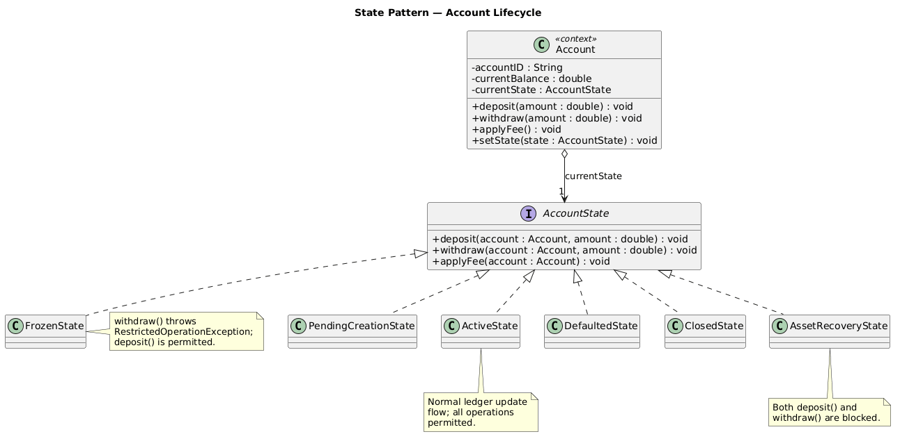

3. Strategy - Interest Calculation Across Account Types
Category: Behavioral

Problem

The bank holds many account products (CheckingAccount, SavingsAccount, FixedDepositAccount, LoanAccount) and each accrues interest under a different formula: a CheckingAccount uses simple interest (or none at all), a SavingsAccount uses daily compounding, a FixedDepositAccount uses compound interest with rate locking, and a LoanAccount uses amortized interest. If interest logic is written directly inside each Account subclass, or worse, as a chain of if (accountType == ...) branches inside a single calculator, then every new product type or every regulatory change to a single formula forces edits across the codebase. UC 11 (Calculate and Apply Interest) must run nightly without modifying to the Account hierarchy each time a product is launched.

How It Works

The Strategy pattern extracts each algorithm into its own class behind a common interface and lets the client object (the *context*) hold a reference to one of these strategy objects. The context assigns the work to its current strategy and never embeds the algorithm itself. Swapping algorithms is a matter of assigning a different strategy object — no conditionals, no subclassing of the context.

Structure in the Project

An InterestStrategy interface declares one operation, calculateInterest(principal, periodInDays, rate). Specific strategies implement it: SimpleInterestStrategy for current accounts, DailyCompoundStrategy for savings, LockedCompoundStrategy for fixed deposits, and AmortizedInterestStrategy for loans. Every Account holds an InterestStrategy reference assigned at creation time based on the product type. The InterestPostingJob (the system actor that runs UC 11) calls account.accrueInterest() on every account; the call assigns to currentStrategy.calculateInterest(...) without knowing the formula.

Example

A new account opened under a promotional "Stepped Savings" product is constructed with a StepRateCompoundStrategy. Two years later, when the promotional period ends, the account is migrated to DailyCompoundStrategy by a single call to account.setInterestStrategy(new DailyCompoundStrategy()) — no edits to Account or to the InterestPostingJob are required.

Pros

- Open/Closed Principle: new interest products (e.g., a stepped-rate savings or an introductory-rate loan) are added by writing a new strategy class, not by editing Account or its subclasses.

- Strategies can be swapped at runtime, so the same Account can be migrated from one interest plan to another (e.g., promotional rates expiring) without changing its class.

- Each strategy is unit-testable independently against known inputs, which matters for regulatory compliance audits of interest formulas.

Cons

- Clients (or the account-creation factory) must know which strategy to assign to which product, so there is one more decision point to maintain in product configuration.

- For a system that genuinely needs only one or two interest formulas, the extra interface and specific classes are more complex than a simple conditional would be.

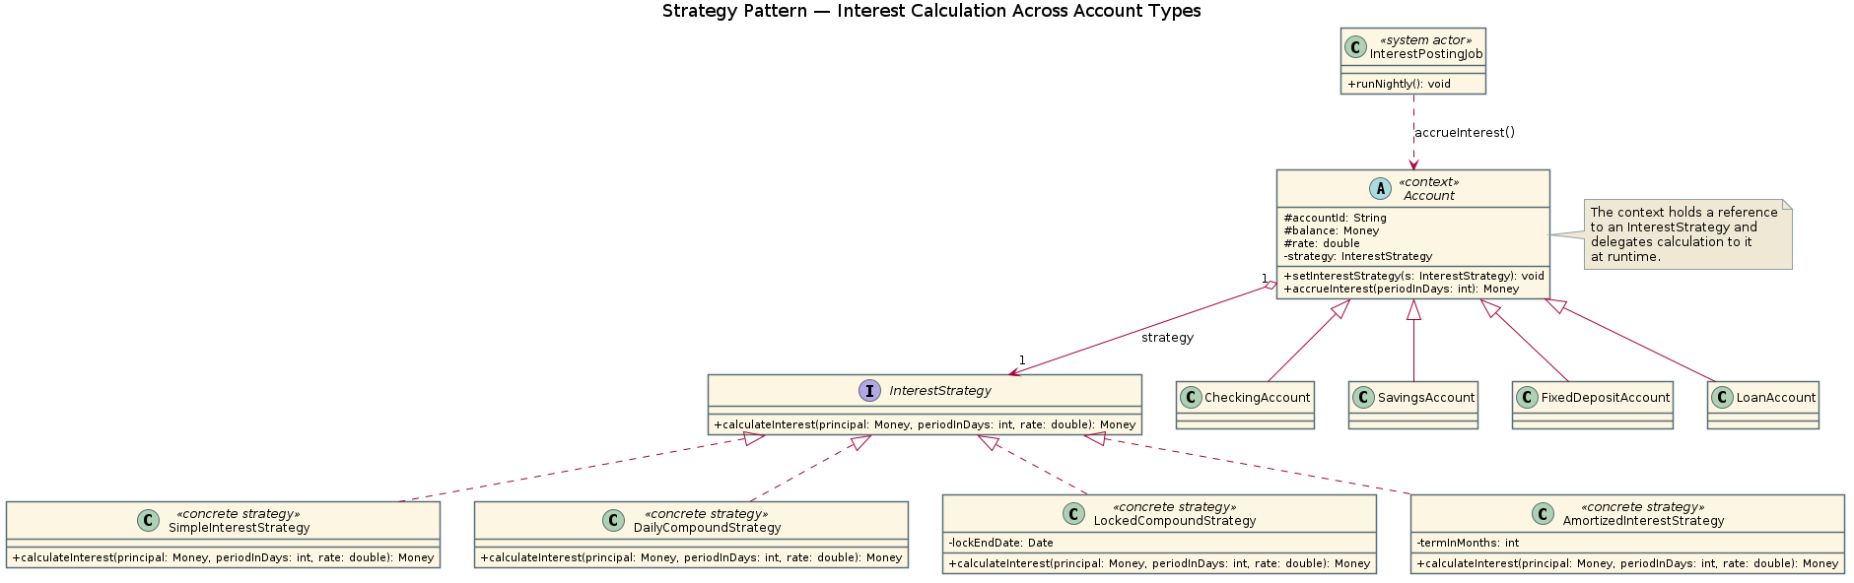

4. Chain of Responsibility – Loan Approval Pipeline
Category: Behavioral

Problem

A loan application cannot be approved by any single actor regardless of amount. A Teller can authorize small loans up to a low threshold; a BranchManager handles the next tier; a SeniorUnderwriter handles larger amounts; and anything above the highest threshold must reach the ChiefRiskOfficer. Hard-coding this escalation inside the LoanApplication class as nested if-blocks tied to specific actor classes makes the rules difficult to track, untestable, and impossible to reorder without modifying. The escalation hierarchy must also handle new tiers (e.g., a RegionalManager inserted between BranchManager and SeniorUnderwriter) without rewriting the loan workflow.

How It Works

The Chain of Responsibility pattern turns each handler in a workflow into a stand-alone object that implements a common interface and holds a reference to the next handler. When a request arrives, a handler either processes it or forwards it to the next link in the chain. Neither the original sender nor any individual handler knows the full structure of the chain, so links can be reordered, inserted, or removed without touching the request code.

Structure in the Project

An ApprovalHandler abstract class declares handle(LoanApplication) and holds a setNext(ApprovalHandler) setter plus a protected nextHandler reference. Specific handlers are TellerHandler, BranchManagerHandler, SeniorUnderwriterHandler, and ChiefRiskOfficerHandler. Each checks the loan amount against its own threshold; if the amount is within its limit it calls approve() and stops, otherwise it forwards via nextHandler.handle(loan). The LoanOfficeService assembles the chain once at startup and submits every incoming LoanApplication to the head of the chain. UC 09 (Approve Loan Application) flows through this chain end-to-end, and the GlobalRiskModel Singleton from Pattern 1 is consulted by every handler so policy stays consistent across tiers.

Pros

- Single Responsibility Principle: each approval tier owns only its own threshold and approval logic; the workflow as a whole is the chain configuration, not a class.

- Open/Closed Principle: a new approval tier (e.g., RegionalManagerHandler) is added by writing one class and inserting it into the chain configuration, with zero changes to existing handlers or to the LoanOfficeService client.

- The chain order is data, not code, so escalation policy can be tuned per branch or per region by reconfiguring the chain rather than recompiling.

Cons

- A loan can theoretically traverse the whole chain without being handled (e.g., a configuration mistake leaves a gap), so the chain needs a default terminal handler that explicitly rejects or escalates beyond the CRO.

- Debugging is harder because the actual handler that processes a given loan is only known at runtime — stack traces and audit logs must record which link approved each request.

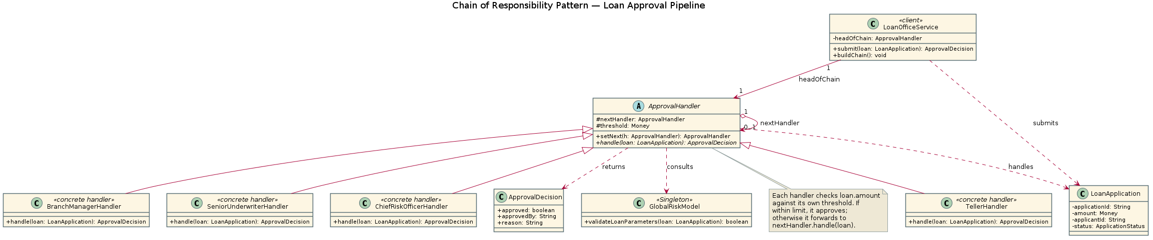

5. Decorator - Shared Requirements on Transactions
Category: Structural

Problem

Every transaction in the system carries the same set of shared requirements regardless of its core operation: an immutable audit log entry must be written (UC 14), the AML/KYC officer must screen it for suspicious activity (UC 13), the customer may need a notification (UC 06, UC 17), and sensitive fields must be encrypted before they cross any subsystem boundary. If these concerns are hard-coded into every specific transaction class (DepositTransaction, WithdrawalTransaction, TransferTransaction, LoanDisbursementTransaction), the code is duplicated four times and every regulatory change requires four edits. Using inheritance to combine concerns ("LoggedAndScreenedAndNotifiedTransferTransaction") explodes into a complex mix of subclasses. We need to attach these concerns *at runtime*, in whatever combination a given transaction type requires, without modifying the transaction classes themselves.

How It Works

The Decorator pattern wraps an object inside another object that implements the same interface. The wrapper adds behavior before and/or after assigning to the wrapped object, and because the wrapper itself implements the shared interface, it can be wrapped again by another decorator. Stacking decorators dynamically lets clients compose any combination of shared requirements behaviors around a base object at runtime, without touching the base class or its existing subclasses.

Structure in the Project

An ITransaction interface declares execute() and getDetails(). The specific components are DepositTransaction, WithdrawalTransaction, and TransferTransaction, all extending an abstract BaseTransaction. A TransactionDecorator abstract class also implements ITransaction and holds a reference to a wrapped ITransaction. Specific decorators are AuditLoggingDecorator (writes to the immutable audit trail required by UC 14), FraudScreeningDecorator (runs the AML check from UC 13), NotificationDecorator (dispatches customer alerts from UC 06 and UC 17), and EncryptionDecorator (encrypts sensitive payload fields before they leave the process). The TransactionFactory builds the appropriate stack for each request, e.g., a high-value transfer is constructed as `new NotificationDecorator(new FraudScreeningDecorator(new AuditLoggingDecorator(new TransferTransaction(...))))`.

Example

A small intra-bank deposit needs only audit logging, so the factory returns `new AuditLoggingDecorator(new DepositTransaction(...))`. An international wire transfer needs the full stack: audit + fraud screening + encryption + customer notification. Both calls to execute() look identical from the caller's side; the difference is entirely in how the stack was assembled.
Pros

- Open/Closed Principle: a new concern (e.g., RateLimitingDecorator, RegulatoryReportingDecorator) is added as one new decorator class without touching any existing transaction or decorator.

- Single Responsibility Principle: each decorator owns exactly one concern, which keeps each class small and individually testable.

- Composition happens at runtime, so different transaction types — or even individual transactions selected by amount or risk profile — can receive different stacks without subclassing.

Cons

- The order in which decorators are stacked matters (e.g., encryption must happen after fraud screening reads the plaintext fields), and that order is a configuration concern that is easy to get wrong.

- A long decorator stack is harder to debug than a single class: a stack trace passes through many wrapper layers, and the actual sequence of behaviors at runtime has to be reconstructed from the factory configuration.

- Constructing the stacks (typically in the TransactionFactory) can be long and cluttered; this is the configuration cost the lecture slides explicitly call out

